Name

Mathematics Advanced Year 11
The Derivative as a Rate of Change

Book 5 |  | Version: 261020  Feedback:  https://MrDingMaths.com
Contents
Syllabus Content 2
Learning Intention 4

Syllabus Content
MAV-11-06 interprets the meaning of the derivative and determines the derivative of functions to solve problems
The derivative as a rate of change
- Interpret $f'(c)$ as the instantaneous rate of change of the function $f(x)$ at $x=c$
- Define and distinguish between displacement and distance and between velocity and speed
- Use graphs of functions and their derivatives, without the use of algebraic techniques, to describe and interpret physical phenomena
- Use the notation $\frac{dx}{dt}$ or $\dot{x}$ to represent the velocity of a particle with displacement $x$ from a point as a function of time $t$
- Solve problems by determining the velocity of a particle moving in a straight line, given its displacement from a point as a function of time

Average Rate of Change

- Average Rate of Change
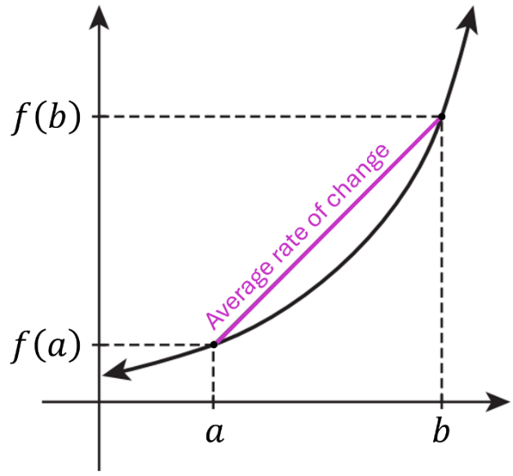
The average rate of change between $x=a$ and $x=b$ is the gradient of the secant.

$$\begin{matrix}Average \\ rate of change\end{matrix}= \frac{Δy}{Δx} \\ =\frac{f\left(b\right)-f(a)}{b-a}$$

- Example Find average rate of change across an interval.
A container is being filled with water.  The volume $V$, in litres, after $t$ minutes is given by  $$V\left(t\right)=t^{2}+t+1$$  Find the average rate of change of volume between $t=1$ and $t=5$  $$\frac{Δy}{Δx}=\frac{V\left(5\right)-V\left(1\right)}{5-1}$$  $$=\frac{31-3}{4}$$  $$=7 L/min$$ | The temperature $T$, in °C, of a glass of water over $t$ minutes is changing according to  $$T\left(t\right)=30×2^{-t}+20$$  Find the average rate of change in temperature over the first two minutes.  $$\frac{Δy}{Δx}=\frac{T\left(2\right)-T\left(0\right)}{2-0} \\ =\frac{27.5-50}{2} \\ =-11.25 °C/min$$

- Practice
A model rocket is launched into the air. Its height after $t$ seconds is given by $h\left(t\right)=-t^{2}+10t$, where $h$ is in metres.
Find the average rate of change of height  between $t=0$ and $t=4$.  $6$ m/s | Find the average rate of change of height  between $t=6$ and $t=10$.  $-6$ m/s

Foundation
- $Q=8t-t^{2}$
  - Find the values of $Q$ when $t=1$ and $t=3$.
7 and 15
  - Hence find the average rate of change from $t=1$ to $t=3$.

4
  - Similarly find the average rate of change from $t=5$ to $t=7$.
$$-4$$

- A bucket full of water has a leak, and the volume after $t$ minutes is given by
$$V\left(t\right)=t^{2}-4t+4$$
where V is measured in litres.
  - Find the average rate of change of V during the first minute.
Remember to have units in your answer.

$-3$ L/min
  - Find the average rate of change of V over the first two minutes.

$-2$ L/min
  - Explain why the model is only valid for t ∈ [0, 2].
What happens to a leaky bucket eventually?

The bucket is empty at $t=2$

- The value of a car, in $, is modelled by the equation $V\left(t\right)= 50000{\left(1.15\right)}^{-t},$ where $t$ is in years. What is the average rate of change in the value of the car over the first five years?

$$-\$5028.23/yr$$

Instantaneous Rate of Change

- Instantaneous Rate of Change
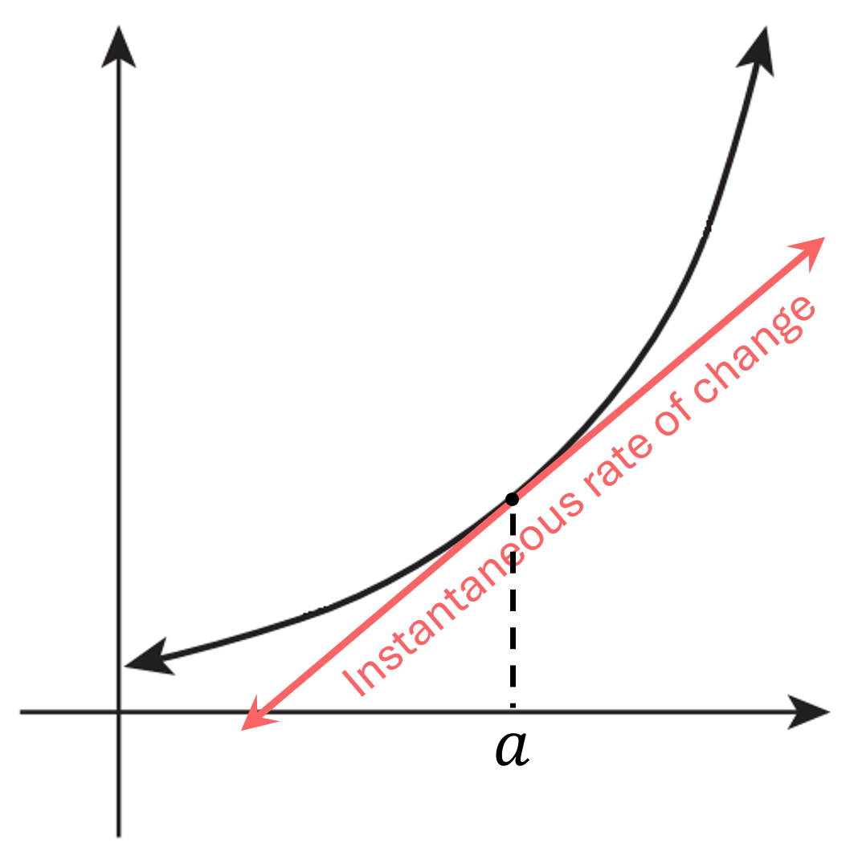
The instantaneous rate of change at $x=a$ is the gradient of the tangent.

$$\begin{matrix}Instantaneous \\ rate of change\end{matrix}= \frac{dy}{dx} \\ =f^{'}\left(a\right)$$

- Identify rate of change formula.
Find the formula for the rate of change of each function.
- $h=50t^{2}+3t$  $$\frac{dh}{dt}=$$ | - $A={\left(h+2\right)}^{5}$ | - $V=7{\left(2t+5\right)}^{3}$
- $y=\sqrt{4-x^{2}}$ | - $S=4πr^{2}$ | - $P=$ $\frac{5+2t}{10-t}$

- Interpret rate of change scenarios.
A ball shoots up and comes down. Its height is $h\left(t\right)$ where $h$ is in metres and $t$ in seconds.
This is what each mathematical operation means.
Find $h\left(a\right):$ Calculate the height at $t=a$ seconds.
Solve $h\left(t\right)=a:$ Find when the ball reaches a height of $a$ metres.
Find $h^{'}\left(t\right)$: Find the rate of change of the height.
Find an equation describing how the height is increasing/decreasing.
Find $h^{'}\left(a\right):$ Find how quickly the ball’s height changes at $t=a$ seconds.
Solve $h^{'}\left(t\right)=a:$Find when the height of the ball is changing/increasing/decreasing at $a$ m/s.
Identify what the following questions are asking you to find.
- What was the height of the ball when it was thrown? | - At what rate was the height changing 20 seconds after being thrown?
- When was the ball at maximum height? | - When was the ball 20 m high?
- When was the ball’s height increasing by $20$ m/s? | - What is the formula that describes the rate of change over time?
The volume of water in a leaky tank is given by $V\left(t\right)$, where $V$ is in litres and $t$in minutes.
- How fast was the water leaking out after 5 minutes? | - How much water was in the tank initially?
- How long did it take for the tank to become completely empty? | - When was the volume decreasing by  $20$ L/min?
The height of a bungee jumper is given by $h\left(t\right)$, where $h$ is in metres and $t$in seconds.
- What was the height of the bungee jumper after 20 seconds? | - When was the bungee jumper’s height increasing by 20 m/sec?
- When was the bungee jumper’s height minimum? | - What was the minimum height of the bungee jumper?

- Example Solve rate of change problems.
A ball is thrown into the air; its height is given by the function $h\left(t\right)=-5t^{2}+20t+1$
where $h$ is in metres and $t$ in seconds.
- Find the initial height of the ball.  $$h\left(0\right)=-5{\left(0\right)}^{2}+20\left(0\right)+1$$  $=1$ m | - Find the initial rate at which the height was changing.  $$h^{'}\left(t\right)=-10t+20$$  $$h^{'}\left(0\right)=-10\left(0\right)+20$$  $=20$ m/s
- Find the height after 3 seconds.  $$h\left(3\right)=-5{\left(3\right)}^{2}+20\left(3\right)+1$$  $=16$ m | - Find the rate at which the height is changing after 3 seconds.  $$h^{'}\left(3\right)=-10\left(3\right)+20$$  $=-10$ m/s
- Find when the ball was at the maximum height.  $h^{'}\left(t\right)=0$  $$-10t+20=0$$  $∴t=2$ s | - Find the maximum height of the ball.  $$h\left(2\right)=-5{\left(2\right)}^{2}+20\left(2\right)+1$$  $=21$ m

- Practice
An infestation of ants hit a Year 7’s locker but was gradually brought under control.
The ant population $P$, in hundreds, $t$ hours after it was discovered, is $P\left(t\right)=7+6t-t^{2}$.
- Find the initial population of the ants.  $P\left(0\right)=7$ hundred | - Find the initial rate at which the population was changing.  $$P^{'}\left(t\right)=6-2t$$  $P^{'}\left(0\right)=6$ hundred per hour
- Find the rate at which the ant population is changing after 4 hours.  $P^{'}\left(4\right)=$ $-2$ hundred per hour | - Find when the ant population was at its maximum.  $$P^{'}\left(t\right)=0$$  $t=3$ hours
- Find the maximum population of the ants.  $P\left(3\right)=16$ hundred | - When were the ants finally eliminated?  $$P\left(t\right)=0$$  $t=-1$ or $7$  They were eliminated after 7 hours.

Foundation
- Find the formula for the rate of change for each function.
- $h = 20t - 4t²$  $$\frac{dh}{dt}= 20 - 8t$$ | - $D = 5t³ + 2t² + 1$  $$\frac{dD}{dt}= 15t^{2}+ 4t$$ | - $A = 16x - 2x²$  $$\frac{dA}{dx}= 16 - 4x$$
- $x = 3t⁵ - t⁴ + 2t - 3$  $$\frac{dx}{dt}= 15t^{4}- 4t^{3}+ 2$$ | - $V =\frac{4}{3}πr³$  $$\frac{dV}{dr}= 4πr^{2}$$ | - $S = 2πr +$ $\frac{50}{r^{2}}$  $$\frac{dS}{dr}= 2π -\frac{100}{r^{3}}$$
- $D = \sqrt{x^{2}- 4}$  $$\frac{dD}{dx}=\frac{x}{\sqrt{x^{2}- 4}}$$ | - $S = 800r +$ $\frac{400}{r}$  $$\frac{dS}{dr}= 800 -\frac{400}{r^{2}}$$

- If $h=t³-7t+5$, find:
  - the average rate of change of $h$ between $t=3$ and $t=4.$

30
  - the instantaneous rate of change of $h$ when $t=3$.

20
- The volume of water $V$ in litres flowing through a pipe after $t$ seconds is given by $V=t²+3t$. Find the rate at which the water is flowing when $t=5$.

13 L/s
- The mass in grams of a melting ice block is given by the formula $M=t-2t²+100$, where $t$ is time in minutes.
  - Find the average rate of change at which the ice block is melting between:
    - 1 and 3 minutes

–7 g/min
    - 2 and 5 minutes.

–13 g/min
  - Find the rate at which it is melting at 5 minutes.

–19 g/min

- The surface area in cm² of a balloon being inflated is given by $S=t³-2t²+5t+2$, where $t$ is time in seconds. Find the rate of increase in the balloon's surface area at 8 $s$.

165 cm² /s
- A circular disc expands as it is heated. The area, in cm², of the disc increases according to the formula $A=4t²+t$, where $t$ is time in minutes. Find the rate of increase in the area after 5 minutes.

41 cm²/min
- Orange juice is being poured at a constant rate into a glass. After $t$ seconds there are $V$ mL of juice in the glass, where $V=60t$.
  - How much juice is in the glass after 3 seconds?
180 mL
  - Show that the glass was empty to begin with.

$$V\left(0\right)=60\left(0\right)=0$$
  - If the glass takes 5 seconds to fill, what is its capacity?

$V\left(5\right)=300$ mL
  - Differentiate to find the rate at which the glass is being filled.

$\frac{dV}{dt}$ $=$60 mL/s
  - What sort of function is the derivative in part d?

The derivative is a constant function.
- The volume $V$ litres of fuel in a tanker, $t$ minutes after it has started to empty, is given by
$V=200(400-t²)$. Initially the tanker was full.
  - Find the initial volume of fuel in the tanker.
80 000 L
  - Find the volume of fuel in the tanker after 15 minutes.
35 000 L
  - Find the time taken for the tanker to empty.
20 min
  - Show that $\frac{dV}{dt}$ $=-400t$, and hence find the rate at which the tanker is emptying after 5 minutes.

Decreasing by 2000 L/min

Development
- The volume of water in a container can be modelled by the equation
$$V =\frac{10-t}{2+t}$$
where $t$ is time in minutes and $V$ is measured in litres.
  - How much water was in the container initially?
5 L
  - Show that $V'(t)=-$ $\frac{12}{{\left(2 + t\right)}^{2}}$

Using quotient rule
$$V^{'}\left(t\right)=\frac{-1\left(2+t\right)-\left(10-t\right)\left(1\right)}{{\left(2+t\right)}^{2}}$$
$$=-\frac{12}{{\left(2+t\right)}^{2}}$$
  - Explain why the container is always losing water.

The derivative $-$ $\frac{12}{{\left(2+t\right)}^{2}}$ is always negative
  - Find the rate at which $V$ is decreasing initially.

3 L/min
  - Find the rate at which $V$ is decreasing when $t=2$.

0.75 L/min

- A ball is dropped from the top of a building, and the distance of the ball from the ground after $t$ seconds is given by the equation $h=100-5t²,$ where h is measured in metres.
  - How tall is the building?
100 m
  - How long does it take for the ball to hit the ground?
$\sqrt{20}=$ 4.47 s
  - Hence, state the time interval $t ∈ [a,b]$ where this model is valid.
$$t∈\left[0,\sqrt{20}\right]$$
  - What is the rate of change $\frac{dh}{dt}$ of the height:
    - initially?
0 m/s
    - when it hits the ground?

$-10\sqrt{20}$ m/s
  - When is the rate at which $h$ decreases the largest?
$t=4.47$, just when it is about to hit the ground.
- A circular disc expands as it is being heated. The area of the disc after $t$ minutes is given by $A = 3t² + t$, where $A$ is in cm².
  - Find the rate at which the area increases after 4 minutes.

25 cm² /min
  - Find the average rate of change during the 4th minute. (4th minute is between $t=3$ and $4$).

22 cm² /min
- The rate of water flow into a tank is given by $\frac{dV}{dt}$ $=10\left(2-t\right),$ where $\frac{dV}{dt}$ is measured in litres per minute. The tank initially had 60 litres of water in it.
  - Describe the difference in the water flow when $t=1$ and $t=4$.
In your answer, refer to the direction of water flow.

The rate is positive when $t=1$ (water is flowing in)
The rate is negative when $t=4$ (water is flowing out)
  - Show that the volume of water increases for a certain amount of time, and then decreases afterwards.

Consider the derivative $10\left(2-t\right)$, it is a decreasing straight line that is positive when $t<2$ and negative when $t>2$.
When $t<2$, volume is increasing, when $t>2,$ the volume is decreasing.
  - Show that the formula $V=20t-5t²+60$ satisfies the given information.

$$\frac{dV}{dt}=20-10t=10\left(2-t\right)$$

- A water tank is being emptied. The quantity Q litres of water remaining in the tank at any time $t$ minutes after it starts to empty is given by $Q\left(t\right)=1000{\left(20-t\right)}^{2}, 0≤t≤20$.
  - At what rate is the tank being emptied at any time $t$?

$2000\left(20-t\right)$ L/min
  - How much time does it take to empty the tank? (When is $Q=0$?)

After 20 minutes
  - At what time is the water flowing out at a rate of 20 000 litres per minute?

After 10 minutes
  - What is the average rate at which the water flows out in the first 5 minutes?

35 000 L/min
- A block of ice of mass 8 kg melts according to the formula $M=8-$ $\frac{t^{2}}{32}$, where $M$ is the mass remaining, in kilograms, after $t$ minutes.
  - Find the time taken for all the ice to melt.

16 minutes
  - Find the rate at which the ice is melting after 4 minutes.

–0.25 kg/min
  - Find the rate at which the ice is melting when 2 kg of ice has melted.

–0.5 kg/min
  - Is the melting rate faster initially, or just before it is gone completely?

It is faster just before it’s gone.

- Water is poured into a tank and the volume $V$, in litres, after $t$ seconds is $V=200+80t-2t²$.
  - Find the amount of water initially.

200 L
  - If the tank was full in 20 seconds, what is the capacity of the tank?

1000 L
  - Find the average rate of change during the first 10 seconds and compare it with the
instantaneous rate of change after 10 seconds.

60 L/s vs 40 L/s
  - When was the flow rate the greatest?

At $t=0$

Mastery
- Water surges into a rock pool, and then out again. The mass $M$ in kilograms of water in the pool $t$ seconds after time zero is given by the function $M=10t-t²$.
  - Find the rate $\frac{dM}{dt}$ as a function of time $t$.
$$\frac{dM}{dt}=10-2t$$
  - Find (with units) the values of $M$ and $\frac{dM}{dt}$ when $t=4$.

$$M=24 kg, \frac{dM}{dt}=2 kg/s$$
  - Find the value of $M$ when $t=2$, and hence find the average rate of change over the time interval from $t=2$ to $t=4$.

$$M=16 kg, avg rate of change=4 kg/s$$
  - At what times is $M$ zero?
$$M=t\left(10-t\right),$$
$0$ and $10$ seconds
  - Therefore, for how long was there water in the pool?

10 seconds
  - How long after time zero is $\frac{dM}{dt}$ zero?

$$\frac{dM}{dt}=10-2t=0$$
$t=$ 5 seconds
  - For how long was the water level in the pool rising, and for how long was it falling?

$\frac{dM}{dt}>0$ for the first 5 seconds and $<0$ for the next 5 seconds
  - Sketch the graphs of $M$ and $\frac{dM}{dt}$ as functions of $t$, showing these results.
Add the chord corresponding to the result in part c and the tangent corresponding to the result in part f.
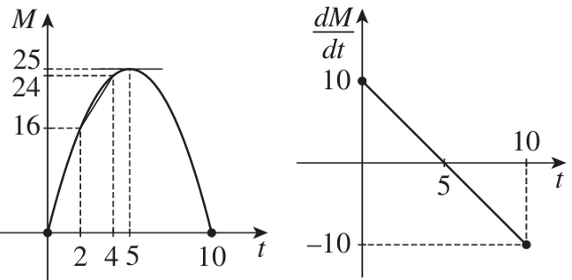

- The share price $$P$ of a bank $t$ years after it opened on 1 Jan 1970 was $P=-0.4t²+4t+2$.
  - What was the initial share price?
$2
  - What was the share price after one year?
$5.60
  - At what rate was the share price increasing after two years?
$$\frac{dP}{dt}=-0.8t+4$$
$$\$2.40/yr$$
  - Find when the share price was stationary.

$t=5$, at the start of 1975
  - Explain why the maximum share price was $12, at the start of 1975.

$t=5$ is the turning point of $P$.
The share price was increasing before then, and decreasing after.
  - Explain why the rate of change of the price decreased at a constant rate.

$\frac{dP}{dt}$ is linear with negative gradient $-0.8$
  - The directors decided to close the bank when the share price fell back to its initial value. When did this happen?

By symmetry of a parabola, it would take another 5 years to go from the maximum back to the starting value.
$∴$ At the start of 1980.

- The graph shows the share price $P$ in a company $t$ months after the start of the year.
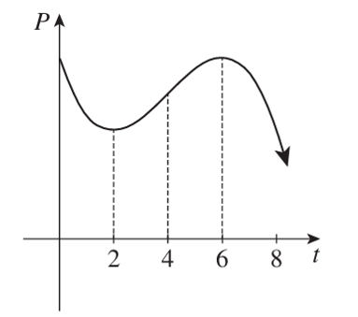
  - When is the price stationary, neither increasing/decreasing?
$$t=2, 6$$
  - When is the price maximum?
$$t=0, 6$$
  - When is the price increasing and when is it decreasing?
Increasing $2<t<6$, decreasing $0<t<2$ and $t>6$
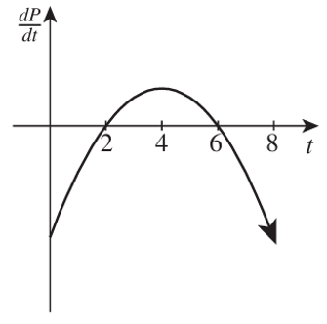
  - When is the share price increasing most rapidly?
$$t=4$$
  - When is the share price increasing at an increasing rate?
Between $t=2$ and $t=4$
  - Sketch the graph of $\frac{dP}{dt}$ as a function of time $t$.

- A lightning bolt hits the ground with a tremendous noise. The noise spreads out across the suburbs in a circle of area $A$, startling people.
  - The speed of sound in air is about $\frac{1}{3}$ km/s. Show that the area $A$ in which people are startled as a function of the time $t$ in seconds after the strike is $A =\frac{π}{9}t²$.

Using distance = speed $×$ time:
$$r=\frac{1}{3}t$$
$$A=πr^{2}=π{\left(\frac{t}{3}\right)}^{2}=\frac{π}{9}t^{2}$$
  - Find the rate at which the area of startled people is increasing.

$$\frac{dA}{dt}=\frac{2π}{9}t$$
  - Find, correct to four significant figures, the time when the area is 5 km².

$$t=\sqrt{\frac{45}{π}}≈3.785 s$$
  - Find the rate at which the area is increasing at that time

$$\frac{dA}{dt} when t=\sqrt{\frac{45}{π}}$$
$$=2.642 {km}^{2}/s$$
- HSC Advanced Sample Question Band 4
A magpie plague hit Sydney but was eventually brought under control. A researcher estimated that the population $M$, in hundreds, $t$ months after 1st January, was $M=7+20t-3t^{2}$.
  - Find the magpie population on 1st March.

$M\left(2\right)=35$, 3500 magpies
  - At what rate was the population changing at this time?
$$M^{'}\left(t\right)=20-6t$$
$$M^{'}\left(2\right)=8$$
Increasing by 800 magpies per month
  - In what month does the magpie population start to decrease?
Find turning point
$M^{'}\left(t\right)=0$ when $t=$ $\frac{10}{3}=3\frac{1}{3}$
Population starts to decrease in April, since $t=0$is January

Applications of Differentiation to Motion

- Displacement, Velocity, Acceleration
- Magnitude is the distance from zero.
- Direction is positive or negative.
- Distance and speed are called scalar quantities, they only have magnitude, no direction.
- Displacement, velocity, and acceleration are vector quantities.
They have magnitude and direction.
- In questions, it is important to define the positive direction to be able to interpret results.
e.g. up is positive, down is negative; or right is positive, left is negative.

Displacement | Velocity | Acceleration
Position relative to a  starting point.  $$x$$  E.g. 3 metres north.  Distance is the magnitude. | Rate of change of displacement over time.  $$v or \dot{x} or \frac{dx}{dt}$$  E.g. 5 m/s west.  Speed is the magnitude. | Rate of change of  velocity over time  $$a or \ddot{x} or \frac{dv}{dt}$$  E.g. 9.8 m/s² down.

- Language of Motion
Initial: $t=0$ At rest/stationary: $v=0$
At the origin: $x=0$ Constant velocity: $a=0$

- Interpret language of motion
Identify what the question is asking you to find, answer in function notation in terms of $x, \dot{x},$ or $\ddot{x}$.

The movement of a particle over time is given by $x\left(t\right)$.
- Find the initial displacement. | - Find when the particle is stationary.
- Find the initial velocity. | - Find when the particle is at the origin.
- Find when the particle is at rest. | - Find the initial acceleration.

- Example Solve motion problems involving differentiation
A ball is dropped from a platform, its vertical displacement is $x=50-5t^{2}$, where $x$ is in metres and $t$ is in seconds.
- Find the initial displacement.  What does this represent?  $x\left(0\right)=50$ m.  This is the height of the platform. | - Find its displacement at 2 s.  $x\left(2\right)=50-5{\left(2\right)}^{2}$  $=30$ m.
- Find its velocity at 2 s.  $\dot{x}=-10t$  $\dot{x}\left(2\right)=-20$ m/s | - Find its acceleration at 2 s.  What do you notice about the acceleration?  $$\ddot{x}=-10$$  $\ddot{x}\left(2\right)=-10$ m/s²  The acceleration doesn’t change.

- Practice
A rocket is launched upwards. Its vertical displacement is $x=-5t^{2}+20t+5$.
- Find the initial displacement.  5 m | - Find the velocity after 3 seconds.  $-10$m/s
- Find when the rocket is stationary.  What is the significance of this point?  $$t=2$$  This is the maximum height of the rocket. | - Find the acceleration of the rocket.  $-10$ m/s²

- Example Interpret graphs of motion
This graph shows the displacement of a particle from the origin as it moves in a straight line.
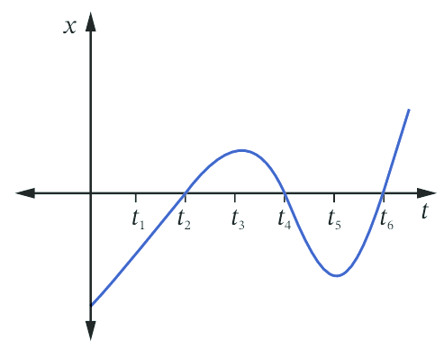
- When is the particle at rest?
- When is it at the origin?
- When is it moving at its greatest speed?

a) The particle is at rest when $v=0$.
The gradient is zero at $t_{3}$ and $t_{5}$

b) The particle is at the origin when $x=0$
$x=0$ at $t_{2}, t_{4}, t_{6}$

c) The speed is greatest when the gradient is steepest.
By inspecting the curve, this happens at around $t_{4}$.

- Practice
This graph shows the displacement of a particle from the origin as it moves in a straight line.
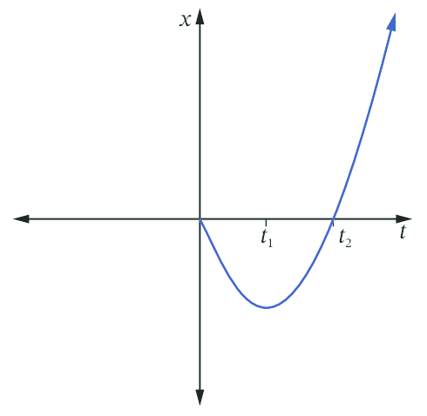
- Find when the particle is at rest.
- Find when the particle is at the origin.
- What happens to the velocity as $t→∞$?
- Sketch a graph of the velocity.

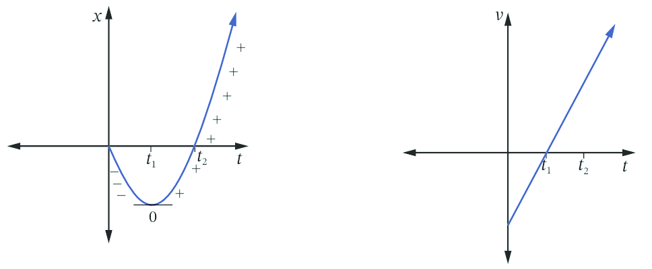

$$t_{1}$$
$$0, t_{2}$$
$v→∞$ as $t→∞$

Foundation
- A car is $d$ km from home after $t$ hours according to the formula $d=10t²+5t+11$.
  - How far is the car from home:
    - initially?
11 km
    - after 3 hours?
116 km
  - At what speed is the car travelling after:
    - 3 hours?
65 km/h
    - 5 hours?
105 km/h
- The displacement of a particle is $x = t³ - 9t$ cm, where $t$ is time in seconds.
  - Find the velocity of the particle at 3 s.
18 cm/s
  - Find the acceleration at 2 s.
12 cm/s²
  - Show that the particle is initially at the origin, and find any other times that the particle will be at the origin.
When $t=0, x=0$
At $t=3$
  - At what time will the acceleration be 30 cm s⁻²?

$$t=5$$
- A particle is moving with displacement $x=2t²-8t+3$, where $x$ is in metres and $t$ is in seconds.
  - Find its initial velocity.
$\dot{x}\left(0\right)=-8$ m/s
  - Show that its acceleration is constant and find its value.

$\ddot{x}=4$, constant acceleration of 4 m/s²
  - Find its displacement at 5 s.
13 m
  - Find when the particle's velocity is zero.
2 s
  - What will the particle's displacement be at that time?

–5 m
- A stone is dropped from the top of a tall building. The stone's height $h$ metres above the ground $t$ seconds later is $h = 80 - 5t²$.
  - How high is the building?
$h\left(0\right)=80$. 80 metres
  - How many seconds does the stone take to reach the ground?
$h=0$ when $t=4$, so 4 seconds
  - The velocity $v$ is the rate of change $\frac{dh}{dt}$ of the height. Find the velocity function.
$$v=\frac{dh}{dt}=-10t$$
  - How fast is the stone travelling when it hits the ground?

At $t=4$, $v\left(4\right)=-40$. It hits the ground at 40 m/s
  - Acceleration is the rate of change dv/dt of the velocity. Find the acceleration of the stone (the units are 'metres-per-second, per second', usually written as m/s²).

$$\frac{dv}{dt}=-10 m/s^{2}$$
- A particle moves in a straight line so that its displacement x m from a fixed point O on the line at any time $t$ seconds ($t ≥ 0$) is given by $x=t²-5t+6$. Find:
  - its initial displacement.
6 m
  - its initial velocity.
–5 m/s
  - when it first passes through O and with what velocity.
$t=2$, $v=$ –1 m/s
  - when it passes through O the second time and with what velocity.
$t=3, v=1$ m/s
  - when and where its velocity is zero.

$t=2.5,$ $x=-0.25$ m
- The displacement $x$ m at time $t$ seconds ($t ≥ 0$) of a particle moving in a straight line is given by $x=t²-5t+4$.
  - At what time is its velocity zero?
$t=2.5$ s
  - What is the acceleration at this time?
$a=2$ m/s²
  - What is the distance travelled in the first 4 seconds?
8.5 m
  - At what time is the velocity 8 m s⁻¹?

6.5 s

Development
- A point moving in a straight line is distant $x$ m from the origin $O$ at time $t$, where
$x=2t³-15t²+36t$.
  - Find the velocity and acceleration at any time $t$.
$$\dot{x}=6t^{2}-30t+36$$
$$\ddot{x}=12t-30$$
  - Find the initial velocity and acceleration.

$36$m/s, –30 m/s²
  - At what times is the velocity zero?

$t=2, 3$ s
  - At what time is the acceleration zero? Find the velocity and position at this time.

$t=2.5$s
$\dot{x}\left(2.5\right)=-1.5$ m/s
$x\left(2.5\right)=27.5$ m
  - During what interval of time is the velocity negative?

$$6t^{2}-30t+36<0$$
$$\left(t-3\right)\left(t-2\right)<0$$
$$2<t<3$$
- Two bodies move along a straight path, starting at the same time, so their displacement $x$ m from a fixed point O at any time $t$ is given by $x = t + 6$ and $x = t² + 4$ respectively.
At what times are they:
  - Together.
$$t+6=t^{2}+4$$
$$t=2$$
  - Travelling with the same velocity?
Velocities of each particle are $\dot{x}=1$ and $\dot{x}=2t$
$$1=2t$$
$t=0.5$ s
- The velocity $v$ m s⁻¹ at time $t$ seconds $(t ≥ 0)$ of a body moving in a straight line is given by $v = 6t² + 6t - 12$. Find:
  - the acceleration when the velocity is zero.

Velocity 0 at $t=1, a=18$ m/s²
  - the initial velocity and acceleration.

At $t=0, v=-12$ m/s, $a=6$ m/s²

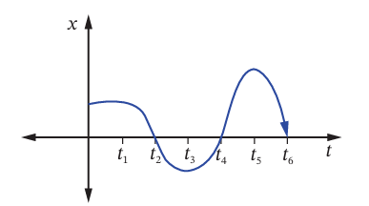
- The graph shows the displacement of a particle as it moves along a straight line.
When is the particle:
  - at the origin?
  - at rest?
  - furthest from the origin?

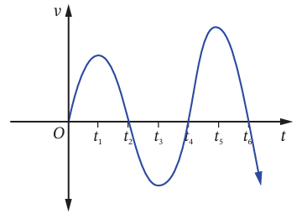
- This graph shows the velocity of a particle.
  - When is the particle at rest?
  - When is the acceleration zero?
  - When is the speed the greatest?
  - Describe the motion of the particle at:
    - $t_{2}$
    - $t_{3}$

- Describe the displacement and velocity of the particle at $t_{1}$ for each displacement graph.
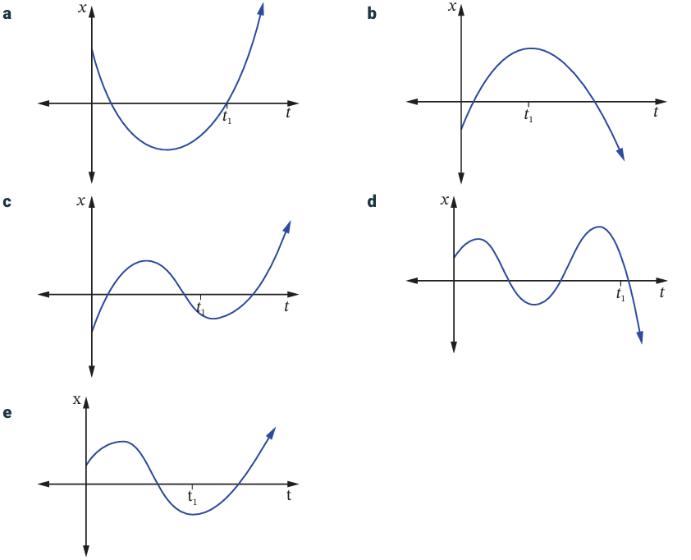

Mastery
- A cricket ball is thrown vertically upwards. Its height $x$ in metres at time $t$seconds after it is thrown is given by $x=20t-5t²$.
  - Find $v$ and $a$ as functions of $t$, and show that the ball is always accelerating downwards. Then sketch graphs of $x$, $v$ and $a$ against $t$.
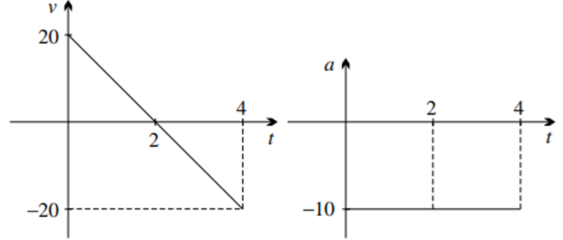
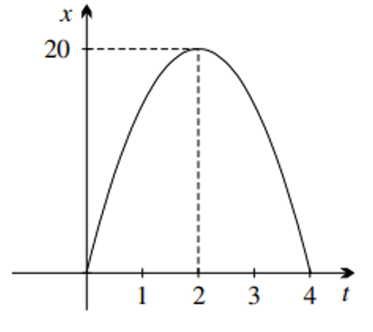
$x=5t\left(4-t\right)$
$$v=20-10t$$
$$a=-10$$

  - Find the speed at which the ball was thrown.
$v\left(0\right)=20$ m/s
  - Find when it returns to the ground (that is, when $x=0$) and show that its speed then is equal to the initial speed.

It returns to the ground at $t=4$. At both times, the speeds are 20 m/s
  - Find its maximum height above the ground and the time taken to reach this height.

Max height at $t=2$s, $h=20$ m
  - Find the acceleration at the top of the flight, and explain why the acceleration can be non-zero when the ball is stationary.

$-10$m/s². Although the ball has stopped, its velocity is changing, meaning its acceleration is non–zero.

- A particle is moving horizontally so that its displacement $x$ metres to the right of the origin at time $t$ seconds is given by the graph.
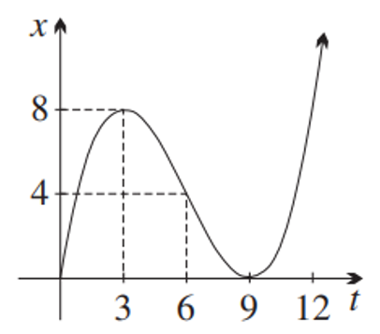
  - In the first 10 seconds, what is its maximum distance from the origin and when does it occur?

8 metres at $t=3$ s
  - By examining the gradient, find when the particle is:
    - stationary,
$$t=3, t=9$$
    - moving to the right,
Moving to the right when derivative is positive.
$0≤t<3$ and $t>9$ (gradient is positive)
    - moving to the left.
Moving to the left when derivative is negative.
$3<t<9$ (gradient is negative)
  - When does it return to the origin and what is its velocity then?
$t=9$, velocity is 0.

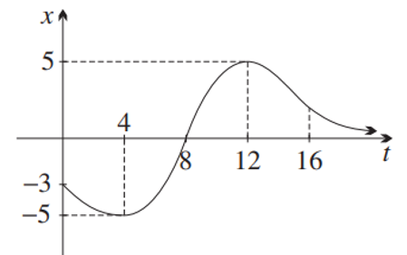
- A particle is moving vertically according to the graph shown, where upwards is positive.
  - At what times is this particle:
    - below the origin?
$$0≤t<8$$
    - moving downwards?

$0≤t<4$ and $t>12$
  - At about what time is its speed greatest?

Gradient steepest at $t≈8$
  - At about what time is:
    - the distance from the origin about the same as at $t=3$?

$$t≈5, 11, 13$$
    - the velocity about the same as at $t=3$?

Gradient of tangent about the same when $t≈13$ and $t≈20$
  - Draw an approximate sketch of the graph of $v$ as a function of time.
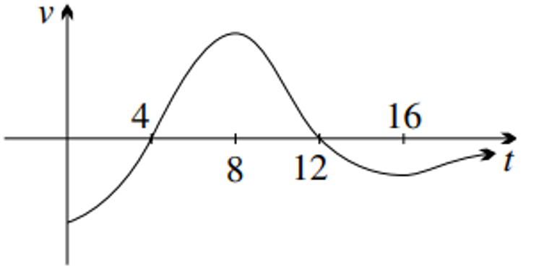

- 2019 HSC Advanced Band 4
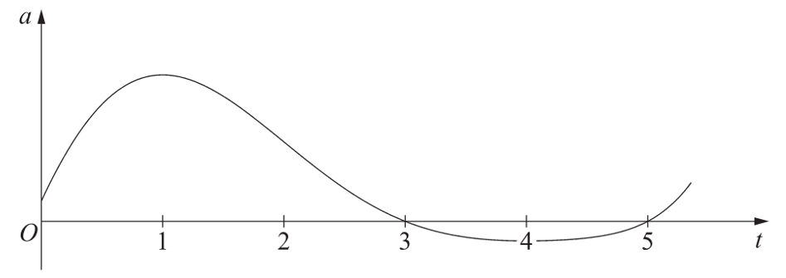
A particle is moving along a straight line. The graph shows the acceleration of the particle.

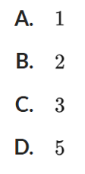
For what value of $t$ is the velocity $v$ a maximum?
C
Velocity is at min or max when $a=0$
At $t=3$, acceleration changes from positive to negative,
so velocity changes from increasing to decreasing.
Therefore, maximum velocity at $t=3$.
In contrast, $t=5$ would be minimum velocity.

